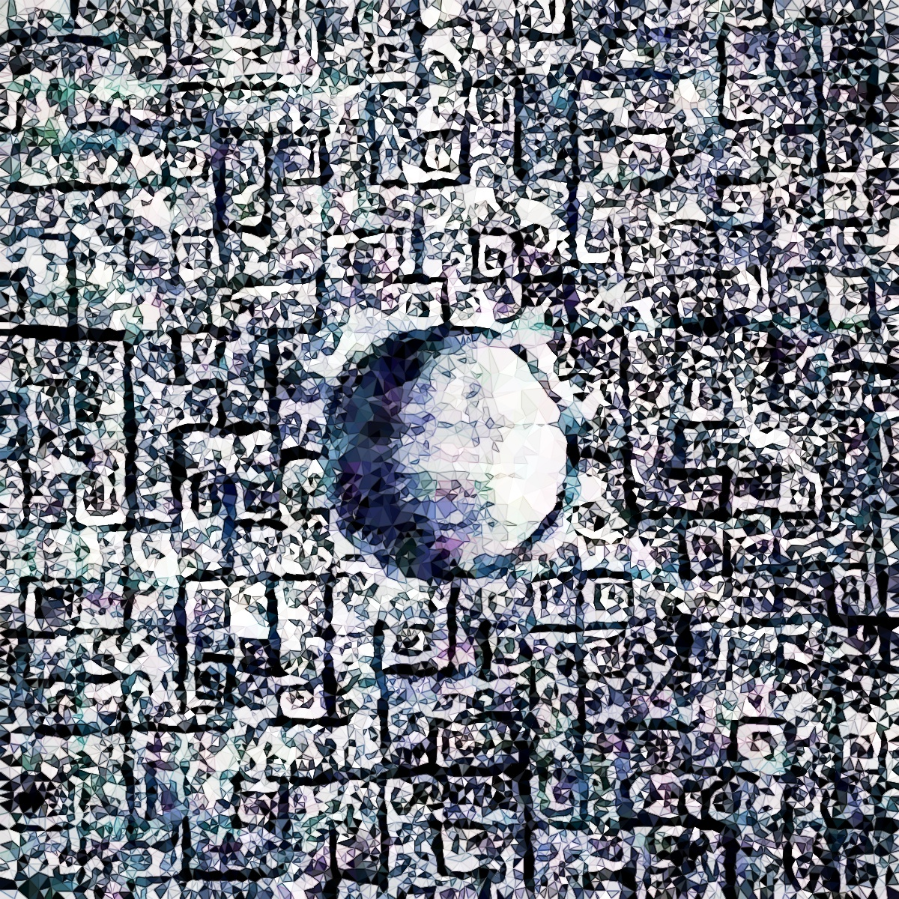

A Maximum Entropy Model for Human Systems Organization.

Whitepaper

Editors:

Joshua Brewster 8/26/2021

Garrett Flynn 9/2/2021

Anna Pacholczyk 11/5/2021

This document only works as a collaborative tale. Please contribute if you enjoyed it and had thoughts about it!

**Table of Contents**

Preface 1

Introduction 4

Maximum Diversity 7

The New Human Rights Movement 10

A Pragmatic Economy By and For Everyone 11

Co-operativized, Decentralized Innovation Engines 15

Co-operative Leap-Frogging to the Next Big Thing: The Game 17

The Importance of Excellence 22

Systems Intelligence 23

Putting It All Together 25

The Future? 28

Appendix 29

Citations 29

**Preface**

The point of this paper is to begin to develop a modern mythos of sorts that we can carry into our daily lives and see the significance everywhere. Most religious or political praxes call on the same impulses, we have an innately narrative and pattern-sensitive consciousness, so it’s important to develop our worldviews independently and conscientiously as this becomes a main driver in our motivation and attention span to get anything done in this life. This is all in good fun otherwise.

The [Corpus Hermeticum](http://gnosis.org/library/hermet.htm) [1] is a curious wisdom text from 2nd century CE. It is a Neoplatonic writing that amalgamates wisdom stretching all the way back to the oldest Egyptian theology, through the Golden Age Greece, and into the late Roman period with some Persian influences. It is a chief example of the “invisible school” of timeless scholarship and natural ethics that has existed as long as humans have had language networks to learn from. The way it’s written is to be a combined voice of all who have written and rewritten its stories, including its translators like Isaac Newton, or for the best English translation by GRS Mead. This tradition spawned the medieval Hermetic Arts of alchemy and magic, which later helped give way to modern sciences like chemistry, physics, modern medicine, and even psychology. Parts of the Hermeticum read like a treatise on the scientific method, and it’s even fairly apparent how someone like Newton might have been inspired to write his theory of gravity as you dig into some of its chapters. To say it was a profound book might be an understatement for its surprising ties to the Enlightenment period and the development of modern sciences much later.

The text is a Socratic dialogue between the hypothetical perfect student, a student healer named Asclepius, and the hypothetical most enlightened teacher Hermes Trismegistus who is trying to help the student develop wisdom. This writing is purposeful in its lack of explicit authorship, and it teaches that none of its wisdom is exclusive nor couldn’t be rediscovered independently since it’s just a story that’s never complete. It is also written and translated in a way that deliberately adds every author’s subsequent voice to it, to become a transmission of wisdom spanning millennia and tens of thousands of miles. The Hermetic tradition was more of a practical tool to find discernment and truth in the world, and to develop the mind dutifully to become better healers, as that was one of the best intentions we could have to guide our greater learning processes. This harkens to the original Buddhist or Vedic traditions as well, which held a similar capacity in their societies.

GRS Mead, a historian trained at Cambridge, following his epic 19th century translation of the Hermetic works, supports this point with his [commentary](http://gnosis.org/library/grs-mead/grsm_pymander_commentary.html) [2]:

*“Here, then, we have another element in the Hermes idea. In fact, nowhere do we find a pure line of tradition; in every religion there are blendings and have always been blendings…*

*One of the greatest secrets of the innermost initiated circles was the grand fact that all the great religions had their roots in one mother soil. And it was the spreading of the consciousness of this stupendous truth that subsequently gave rise to the many conscious attempts to synthesize the various phases of religion, and make ‘symphonies’ of apparently contradictory philosophical tenets. Modern research, which is essentially critical and analytical, and rarely synthetical, classifies all these attempts under the term "syncretism" -- a word that it invariably uses in a depreciatory sense, as characterizing the blending of absolutely incompatible elements in the most uncritical fashion. But when the pendulum swings once more towards the side of synthesis, as it must do in the coming epoch -- for we are but repeating today in greater derail what happened in the early centuries -- then scholarship will once more recognize the unity of religion under the diversity of creeds and return to the original doctrine of the Hermetic Mysteries.“*

The beauty is that from all this we developed our modern communication and systematic thinking abilities, and things like mathematics and general theory let us connect anybody anywhere through symbols and systems. This wisdom-become-science has stood the test of time and countless empires, and we’re able to look back through a fascinating lens to see how our wisest ancestors saw the world across time. From there we can learn from history in an intersubjective and scholarly way. The text itself is a testament to this profound intersubjectivity afforded through different forms of language, which is core to human development and society. Science is made of this process, culture too, and a more honest and collectivized form of it will be completely transparent about this borderless, generally flawed, but mutually beneficial linguistic process made beautifully clear in old wisdom traditions.

We’re starting with this because the text you’re reading now ought to be edited, re-edited, translated, etc. by whoever comes along and sees something missing, or sees the need to pass the ideas on, if it is worthy. The authors and editors take ownership of none of this writing, it is effectively a free source, and none of it is original - other than perhaps the overall hot take on reality and what to do about it that we’re ready to serve you up with.

So real talk now; this is the 21st century, the human experiment appears to be in dire straits as we continue to carve up the planet to exploit every last resource, and more people continue to blindly march forward in bizarre lifestyles that only capitalize on, and are made possible by, those precious resources. The world economy has been driven by stratification within and between societies, nationalistic speculation, and colonial rule for a very long time. Wars, colonization, and lacking infrastructure have left generations of people traumatized, malnourished, and facing arbitrary scarcity. The created gaps are then filled by mass marketing, misinformation, or plain propaganda. Those trying to participate in world decisions must also participate in egregious material and virtual exploitation through business and finance in order to accrue enough material power, a process which only aggravates the atomization of more people born into this system from a disadvantaged and uninformed position. This has created a sort of collective schizophrenia, where we find ourselves isolated into little plateaus of activity and belief and personality—completely unaware and untrusting of each other in many ways, and both conditioned and pushed into exploitative relationships with those we’ve externalized.

The obvious truth is there’s no separation. Water starts in the mountains, runs down the rivers, out to the oceans, and comes right back again through the sky - and continues to shape the land the whole way, while the trees and plants encourage this process. The water is language, and the land is us. This is a shared ecosystem, and we all have a part to play to shape and guide and help everything flourish. The only thing separating us is our subjective experience of separateness, but you’d never know that coming through most education or social systems or taking a look at any society in the world where clear strata exist, and many people are condemned to suffer and die through sheer bad luck of where and who they were born to. That inevitably reaches all of us, and the more we pollute the waters and the more we rot the land, the worse it’s gonna be for everyone regardless of their material comforts. The loss of culture and history that ensues with an environmental collapse will leave a world truly not worth living in or living for.

What’s the answer then? Is there one? The arctic is melting at [several degrees](https://www.theguardian.com/us-news/ng-interactive/2020/oct/13/arctic-ice-melting-climate-change-global-warming) [3] above normal average temps (which is still an understatement of the real severity of the problem), there’s giant methane pits in the permafrost opening up in Alaska, Canada and Russia, thousands of Alaskans are already being displaced along with people in the Gulf of Mexico and Oceania from rising temps and sea levels, or Africa and Asia from desertification. Southwestern US is drying out, and we’re trying to frack or grow cash crops on even more of it. South America has a polluted and increasingly burned-up Amazon—including massive oil spills in Ecuador, and big parts of Africa and the Middle East were already turned into dust bowls ten thousand years ago from ancient exploitation—not to mention all the exploitation since the colonial days in the 18th and 19th centuries on. There’s also [ocean acidification](https://www.nature.com/articles/s41598-020-75293-1) [4], the polluted gulfs of the world, the [Pacific garbage patch](https://www.nationalgeographic.org/encyclopedia/great-pacific-garbage-patch/) [5], etc.. Economically we have some of the worst [financial stratification](https://www.marketwatch.com/story/its-been-almost-a-100-years-since-the-americas-1-had-so-much-wealth-2019-02-11) [6] in modern history globally, and the USA could be considered to have a [caste system](https://www.youtube.com/watch?v=n-2TEwdRnX0) [7] in spite of having the largest national pool of resources in the world. Agriculture is a massive disaster too, and is eating up so much of the dwindling water and arable land supply through highly inefficient monocropping methods. As a result of all of this, things like species extinction, [mental illnesses](https://mhanational.org/issues/state-mental-health-america) [8] or in some cases even [poverty](https://www.icwa.org/india-farmers-raise-alarm-over-poverty/) [9] are at unprecedented levels, while the only answer seems to be more exploitation as we find more ways to monetize all of this suffering and lack of education or networks of solidarity.

The reality is that the current dominant policy and economic engine driving human activity on Earth likely cannot be stopped from the inside. It is reinforced by the fact that hundreds of millions of people survive off of this system due to the money from that system determining their immediate survival outcomes. This is Smith’s Invisible Hand of the Market working exactly how it should, and yet failing to deliver a decent way of life. People will not just stop tomorrow and throw their hands up because no viable alternatives are perceived by them, and humans follow the path of least resistance for whatever given set of choices they can conceive of. Naturally then, the only option is to come up with a new and more effective resource system, with a better system of incentives which present better, easier choices, and get the flow of human activity to trend in a healthier direction. There’s the people’s needs and all that to consider, too.

As children of the modern world, we’re exposed now through the internet and media to absolutely everything. The different realities, the wild emotions, the engrossing aesthetics, the gross misinformation, the deafening impulses, etc. It’s all right here, though the vast majority are not accessing and conceptualizing it in a useful way very often. We need to take advantage of our new super powers in the modern era to develop not just our minds but also the reason to seek and develop ways to build a future worth giving a damn about; and find ways to easily extend these fresh perspectives to those without so much time and access as others - or especially to include, empower, and ensure representation of those that cannot readily stand up for themselves.

**Introduction**

The Principle of Maximum Entropy is an information theory idea stating that the best model is that which allows the most uncertainty, and is a statistical version of Occam’s Razor. In other terms, the system that generalizes to the most possible choices will be a better (i.e. more effective & efficient) problem solving system. Nature follows the path of least resistance, meaning in a way it understands immediately the full breadth of choices it could make, say to let a drop of water run down a window pane. In a way, it’s already evaluated most or all possible choices that semi-independent phenomena could make, and goes straight for the “right” one, or the one that follows gravity, or the one that follows the most sensible “choice” given the constraints.

This has serious implications in deep structural modeling in physics and machine learning, where incredibly complex systems often have highly generalizable structures within them that give rise to their emergent yet often highly ordered complexity. The human body is the perfect example of this, as it emerges from genetic codes and stem cells into an unfathomably complex organism—and all life on Earth follows the same basic structure to become the whole ecosystem. You can begin to see how the Earth may be thought of as one larger organism organized by yet greater more unfathomable axioms. This idea also explains quantum phenomena at their most base.

See, the original writers in quantum mechanics studied complex systems in general. Schrödinger himself, in his famous [cat paradox paper](http://hermes.ffn.ub.es/luisnavarro/nuevo_maletin/Schrodinger_1935_cat.pdf) [10], says:

“*The remarkable theory of measurement, and apparent jumping of the wave function, and finally the ‘antinomies of entanglement,’ all derive from the simple manner in which the calculation methods of quantum mechanics allow two separated systems conceptually to be combined together into a single one; for which the methods seem plainly predestined. When two systems interact, their wave functions, as we have seen, do not come into interaction but rather they immediately cease to exist and a single one, for the combined system, takes their place… [and] ‘acts in the space of a much higher dimension number’ than the individual functions… and moreover does not again divide up, after they have again become separated… Thus one disposes provisionally (until the entanglement is resolved by an actual observation) of only a common description of the two in that space of higher dimension. This is the reason that knowledge of the individual systems can decline to the scantiest, even to zero, while that of the combined system remains continually maximal. Best possible knowledge of a whole does not include best possible knowledge of its parts - and that is what keeps coming back to haunt us.*”

This point when the combination occurs and a new system and equilibrium takes precedence, as taken from a 2014 paper on the[*Open Systems Dynamics of Entanglement*](https://arxiv.org/abs/1402.3713) [11], occurs when the subsystems are brought to a point of ‘maximum entropy’, as in they can no longer be predicted deterministically due to their maximal probability spread, yet are locked into a new sort of flow state in a larger system. This is all functional in the greater scheme of energy tending toward the path of least resistance in the entropic universe, which includes more efficient yet spontaneous systems formation in that process that look like nonlinear changes in energy use. To quote from the 2014 paper:

“*Maximally entangled states possess a remarkable property: the reduced density matrix of the smallest subsystem is given, for finite-dimensional systems, by the maximally mixed state, with the identity operator. This contains no information at all (maximal entropy) and therefore any measurements on it yield completely random outcomes. Still, the available information about the whole two-qubit system is maximal, because the state is pure (zero entropy). This is the formal statement of Schrödinger’s quotation already mentioned in the introduction: ‘The best possible knowledge of a whole does not include best possible knowledge of its parts’.”*

This is all more easily understood by looking at your hand and waving it around then trying to figure out how it worked without looking at the rest of the body. It would make absolutely zero sense even though you could completely break down every cell and atom in it to their pure components. Therefore you could get it to a point of knowing every possible state the hand could be in, yet understanding none of why it ends up in one position or the next without some incredible raw predictive powers and tons of controlled data. What Schrodinger then challenges us and modern physics with is a perspective that systems are not just real, they’re hyperreal and can overrule more fundamental behaviors once things start to bump into each other.

Philosophers like Rod Swenson in [*Thermodynamics, Evolution, and Behavior*](https://www.ethics-based-on-science.com/uploads/2/8/5/1/28516163/mjm-notes-entropy-and-evolution-ordered.pdf) [12] see this interesting entropy and systems relationship logically leading to the idea that the whole Earth itself is organized systematically like this, and that life itself is synchronizing on a massive scale, the whole universe too in some basic way (see the cosmic web). Swenson concludes: “*Rather than being infinitely improbable ‘debt payers’ struggling against the laws of physics in a "dead" world collapsing to equilibrium and disorder, living things and their active, end directed striving or intentional dynamics can now be seen as productions of an active order producing world following directly from natural law.*”

There are more interesting overlaps with social systems theories and quantum theories as described in [*Quantum and systems theory in world society: Not brothers and sisters but relatives still?*](https://journals.sagepub.com/doi/10.1177/0967010619897874) [13]

*“What is at stake is the possibility to say something meaningful about international relations’s purported subject matter(s), if the starting points are quite different world-views about the basic characteristics of the (social) world’s fabric, as well as the guiding questions of (social) theory that arise from that. Both quantum and systems theories require thinking about this fabric, including its basic textures such as levels and micro–macro distinctions, and how it is always contingently, yet not arbitrarily, continued out of a myriad of potentialities. Through the concepts of the observer and meaning, and through the recursivity built into them, quantum and systems theory can account for this fundamentally self-referential and partially paradoxical reality. It is because of this that both are counter-intuitive: at the end of the tunnel, neither promises theoretical closure nor a complete view of the world.”*

Consciousness even cannot be understood as anything but an emergent systems or “field” phenomena. This isn’t advocating for some pseudoscientific quantum consciousness trope, but rather that we need to challenge ourselves to adopt a broader scope here for the reality we all inseparably live in together, one that cannot be atomized or pulled apart to say we’re separated by anything but space and time. Harvard professor Leonid Perlovsky, in Neural Networks and Intellect: Using Model Based Concepts writes that the “*concept of the physics of the mind as a neural field of interactions between internal and external signals was originated by [Stephen] Grossberg. His and [Gail] Carpenter’s adaptive resonance theory describes perception as a resonance between internal and external signals. Modeling field theory can be viewed as an extension of this concept toward internal signals being generated by internal models, whose adaptation constitutes learning, leading to an ever increasing complexity of the internal model.*” These “models” are literal assemblies of cells and their [resonant activity patterns](https://www.youtube.com/watch?v=xBwl_bUDMaM) [14].

We humans exist in such a high level of complexity and information processing ability that we also get to craft more or less arbitrary systems or models out of that; a fancy way to say that we have an imagination. That’s a certain kind of art, and the best of it seems to plainly demonstrate this sort of relationship we have with the world and the deep structural harmonies underpinning it. Our brain seems to be [a clear reflection of that](https://www.frontiersin.org/articles/10.3389/fnhum.2014.00020/full#B160) [15] with all of its biology and time-engineered solutions to natural problems like path finding, controlling body movement, sensory processing, memory, attention, etc. “*To know is to possess, & any fact is possessed by everyone who knows it, whereas those who feel the truth are possessed, not possessors.*” - EE Cummings

[Donald Hoffman](https://www.youtube.com/watch?v=3MvGGjcTEpQ) [16] likes to remind us that evolution only pushes our senses to where they need to be for survival. And Nietschze likes to remind us that free will is not a cucumber. The context of survival has expanded with the creation of human societies and all of the benefits and problems it came with. The reason we’ve kept societies has a lot to do with the fact it is both a better source of energy and also now really the only source of energy for so many people unless you’re either lucky enough or bored enough to live off the land. One could say it’s a deep pocket to attract our natural gradient-descent decision making and really would probably kill us otherwise to not deal with it somehow - especially depending on where we’re from.

**Maximum Diversity**

One takeaway from both brain science and ecology is that diversity is good and improves life’s overall ability to build resilience. For brains, the diversity of its systems and subsequent exposure to the environment in order to develop those systems are what help you grow into a more capable person. In ecology, diversity creates more dynamics in the environment which generally only ends up enabling more diversity, as the ecosystem is reinforced by all of the often symbiotic processes occurring. These are both examples of much larger and more interesting systems of their own forming on top of many similar but semi independent parts.

Relating back to the maximum entropy grand conspiracy we’re floating here, we’re looking for the best generalized system to solve the most problems. Well for one, the brain only developed to the degree it has in humans because of the incredible diversity of the world and each other that we’ve been exposed to, and to remove any amount of that is to condemn ourselves to a more limited future in body and mind. Secondly, the more we enable more (ethical) possibilities, the more there may arise a more egalitarian and environmentally friendly economy that serves more benefits to more people and the surrounding ecology. This means giving more people more knowledge, better food, more tools, more networks, as well as restoring and even enhancing our ecosystems.

The latter has been done before, huge areas of Central and South American jungle were [cultivated](https://www.bbc.com/news/world-latin-america-39149334) [17] by humans creating foot paths to cross the swamps to each other’s villages. People survived for thousands of years in the arid American Southwest with strategic intercropping methods but also ended up inducing their own droughts as populations grew. Their canyon valleys were filled with wild sheep and perennial groves of peach trees and grapes they stewarded for centuries, which ended with Spanish and American diseases (including the sheep), scorched-earth genocides, and resettlement. [Permaculture](https://modernfarmer.com/2016/04/permaculture/) [18] could solve the biodiversity and yield problem simultaneously in agriculture and has been demonstrated in [India](https://www.resilience.org/stories/2018-08-03/harvesting-hope-the-permaculture-movement-in-india/) [19] especially to promote both biodiversity and economic independence in otherwise exhausted and externally dependent lands. [Vandana Shiva](https://www.youtube.com/watch?v=6Eymv-PaJsw) [20], a quantum physicist and outspoken advocate for ’agroecology’ which includes permaculture in its toolkit, has a wonderful perspective on this in an article from Yes Magazine titled [What Would Nature Do?](https://www.yesmagazine.org/issue/nature/2019/05/03/vandana-shiva-seed-saving-forest-biodiversity) [21] “*It is from the Himalayan forests and ecosystems that I learned most of what I know about ecology. The songs and poems our mother composed for us were about trees, forests, and India’s forest civilizations... ‘What do the forests bear? Soil, water, and pure air. Soil, water, and pure air Sustain the Earth and all she bears...’ Biodiversity has been my teacher of abundance and freedom, of cooperation and mutual giving. When nature is a teacher, we ­cocreate with her—we recognize her agency and her rights... The war against the Earth began with this idea of separateness. Its contemporary seeds were sown when the living Earth was transformed into dead matter to facilitate the industrial revolution. Monocultures replaced diversity. “Raw materials” and “dead matter” replaced a vibrant Earth. Terra Nullius (the empty land, ready for occupation regardless of the presence of Indigenous peoples) replaced Terra Madre (Mother Earth).*”

Shiva is a major critic of biodiverse crops being replaced with aggressive debt and scarcity-inducing monoculture cropping practices in India where vast swaths of land have been made barren with overly commodified crops. Hundreds of thousands of Indian farmers have taken their own lives in the process. She then quotes Rabindranath Tagore, a Nobel laureate poet: “*Indian civilization has been distinctive in locating its source of regeneration, material and intellectual, in the forest, not the city. India’s best ideas have come where man was in communion with trees and rivers and lakes, away from the crowds. The peace of the forest has helped the intellectual evolution of man. The culture of the forest has fueled the culture of Indian society. The culture that has arisen from the forest has been influenced by the diverse processes of renewal of life, which are always at play in the forest, varying from species to species, from season to season, in sight and sound and smell. The unifying principle of life in diversity, of democratic pluralism, thus became the principle of Indian civilization.*”

Moreover, the agricultural system needs to change to be energy efficient. Current industrialised food production is heavily dependent on fossil fuels, water-intensive and energy inefficient. Fossil fuels are used in agricultural infrastructure (e.g. to power irrigation systems in dry agricultural land such as in Arizona), agricultural production (fertilizers, heavy agricultural machinery) and transport. The energy that needs to come from outside into the farm system, has been called agroecosystem societal inputs (ASI). In traditional agriculture, energy input from outside was low - for example imported livestock feed to help with local scarcity. In modern agriculture, it is high and includes energy used to produce, run and repair agricultural machines, and energy needed for imported feed, synthetic agrochemicals and fertilisers. Our current food production is not sustainable - it depends on heavy input of energy from fossil fuels.

What is worrying is that while we currently produce enough food (famine is due to poor access to food, food being in wrong places in the world and waste), we might only be able to feed half of the current world population without the use of nitrogen fertilizers. The production of ammonia pushed forward industrialisation of food production, which - despite its negative consequences and increased use of arable land - quadrupled agricultural outputs. Yet, about 11% of U.S. adults and 18% of U.S. children experienced food insecurity, despite the U.S. having the 4th highest average annual income. Currently, we are using about 1-2% of global energy on producing fertilisers alone. 60% of energy input in agriculture is related to fertilisers [Rhodes]. Moreover, the Green Revolution (1940s) attributed to Borlaug, who developed more resistant and fertilised varieties enabled eradication of widespread famine (e.g. in India and China) by making more productive crops, and even made it possible for some countries to be more self-sufficient in food production (e.g. Mexico’s wheat production). While those crops saved many lives and went far to realise the idea of fulfilling the basic needs of many in poorer countries, it also led to dependence on fertiliser, radical reduction of the variety of crops being grown and crops with poorer nutritional content. More energy effective, sustainable and nutritionally adequate alternative ways of food production need to be found if we are to be able to feed the world, and avoid the grim predictions of 50% population reduction by 2100 made by some. The initial development of ‘energy smart’ farming methods show that the energy input can in fact be halved while maintaining high productivity. Permaculture, holistic management, regenerative organic agriculture [Rhodes 2017], low-input agriculture, traditional ecological knowledge (TEK) approach [Shramski et al 2011] were proposed as solutions, with the help of practices such as small-scale urban food growing, seed saving, etc.

To make matters worse, the industrialised food system is often energy inefficient: it consumes a lot of energy for production of food. This means that we have to look at energy returns on investment (EROI) for different food production methods. Although estimates vary, a reasonable estimate is that the US food system expends 6-12 calories per one calorie consumed in food, clearly showing a necessity to rely on input of external energy into current food production. The estimates of pre-industrial societies suggest that 1 calorie gained in food would necessitate 0.2 calories expended, which is easy to see in areas where people still rely on abundant subsistence resources. The impact of industrialisation has not been the same in every aspect of managing the land - while EROI in agriculture was affected negatively, the mechanisation of forestry, for example, did not impact energy efficiency negatively. Deforestation due to overuse is another problem, but at least the process when we want to use wood from the forest is energetically reasonable! Any sustainable food production looks at input-output energy balance, builds on balance with local ecosystems, and is related to local de-centralised systems of food production, processing and distribution [Shramski 2011].

Another major problem is that monoculture, overfarming and the use of agrochemicals destroys the soil, which is a process that might be difficult to reverse, and at times might be irreversible. Once eroded, soil is not easily replaced: it takes 200-1000 years to create 2.5cm of soil. Soil degradation and erosion already is impacting productivity: some areas (e.g. Africa) suffered degradation of 20-40% of agricultural land, with an overall 8% decrease in food production because of it. This cannot continue, and many (e.g. Shiva, Rhodes, the United Nations Environmental Programme) proposed methods of sustainable agriculture, which minimise input of non-renewable fertilisers. Rhodes also highlighted the need for regeneration of soil and its biodiverse ecosystem. In Alaska, in its healthy and biodiverse ecosystem, one cubic meter of living soil might contain a million different species of microfungi alone, according to local expert Gary Laursen, underscoring the need to be sensitive to nature when cultivating it for our needs.

The food production system needs to change, and a systemic view can help with the needed transition. And the change really needs to be systemic. As Marechal (2010) noticed, we are in a situation “where the current carbon-based Socio-Technical System constrains and shapes consumers' choices through structural forces”. If we are to make choices that enable taking care of ourselves and our ecosystem, this is only possible if the system changes, so that those choices are available. The move to permaculture, holistic management and regenerative organic farming requires both a systemic view and a systemic shift. While such large scale changes are at times difficult, there is hope. World agriculture contributes 24% to global CO2 emissions, and with intensifying focus on reducing emissions and combating climate change, the shift may be receiving more and more public backing and - hopefully - institutional and financial support. Focus on biodiversity and diversity of locally-applicable solutions will additionally help.

Essentially, a maximum bio and cultural diversity emphasis helps us end up with a system where everyone has a choice to basically do anything meaningful to them and we ensure they and the whole earth around them are cultivated to enable them to do so (within their own capacities, we’re all different of course). We know on principle that we as a community would find ways to make this work for everyone, and make sure we cover all of each other’s needs while we continue to enhance our collective quality of life. In fact the sustainability of our systems is indicated by individual health and wellbeing through diet and the wellbeing of people and communities involved in making food. We will talk more about interconnections in our biopsychosocial sphere next.

**The New Human Rights Movement**

Let’s pull out another metaphor from that Schrodinger quote in the Intro and misuse it for political purposes: “*...until the entanglement is resolved by an actual observation.*” Global systems are run on increasingly complex economic and political engines that have all kinds of game theories built in meant in some part to obfuscate the nature of the economic and social system to create competitive advantages for some and power structures that do not benefit all. Most of this seems to have run so far away in complexity from even the politicians that it’s essentially reinforcing itself without any one person’s input. Even the most wealthy and capable of mobilizing are seemingly powerless, while there are clearly countless lives at stake from these systems failing e.g. from overstressing the environment or ending up at each other’s throats over resource and Human Rights issues.

Schrödinger is here to teach us the lesson that if you observe the system it can resolve and vanish. This is a big stretch from a physics experiment, okay, but humans have this special capacity to get really pissed off and shut things down when they know something is ethically and morally not okay. Humans are also easily conditioned or neglected to not ever develop that awareness and even to commit atrocities. When we educate and empower communities against what is really impacting them both positively and negatively, we can help each other respond to or even completely cure issues through systemic changes and ensuing chains of individual actions made to form a new network. The majority of people in most communities around the world have that capacity, but enough time and powerlessness and bad actors can make them invisible and fragmented. These are the people often never afforded the wisdom and resources they deserve, and are also the ones most capable of transforming their communities for good. Everything has to happen bottom-up, with attention to local needs and solutions. The people are what make their communities.

Now let’s take a page from Peter Joseph’s latest book as of 2021, [The New Human Rights Movement](https://www.google.com/books/edition/The_New_Human_Rights_Movement/TrhCDgAAQBAJ?hl=en&gbpv=1&dq=the+new+human+rights+movement&printsec=frontcover) [22]:

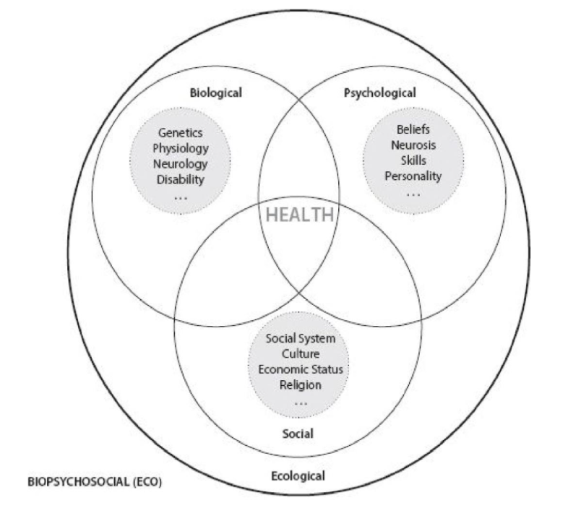

Underpinning this understanding of community is an integrative eco-biopsychosocial perspective on human health (figure from Chapter 1) that draws clear relationships between exterior and interior influences on humans. Note that ecology envelopes everything else about our health as it is the wider system we’re embedded in. Of the many things Joseph has to say about the interactions between humans and their environment throughout the book: “*How the human being intersects with his or her environment, whether social or ecological, is fundamental to all human sciences. A core observation is that we appear to be built with certain biopsychosocial propensities and expectations. In other words, we have hard-wired aspects linking our biological and psychological selves to the social condition. We have evolved not only basic physiological needs but also psychological ones built around our social nature. Just as we completely depend on adults for survival in the first years of life, evolution has wired us for social connection and bonding in deep and profound ways throughout the life cycle.*”

At the end of the day, humans have needs, and again it’s only by satisfying those needs that we can thereby transcend them, meaning we can move on to change our environments and our minds. When accounting for the diversity needs our brains and bodies truly need, too, that also means sufficing the needs of the environment (or: assuring conditions for continued existence of the ecological and social systems that maintain our existence and flourishing). Even more, this might mean improving our social environment to reap the benefits of its increased stability, resilience and opportunities enabled by diversity. Our social and ecological environment includes other people as much as other species. With this broad systemic model of human health in context, Peter Joseph writes further that the reason we aren’t smacked in the face with this thinking at all times is because:

“*First, regardless of the science, this kind of thinking is very counterintuitive. We tend to perceive in very linear and superficial ways, as opposed to broader, more thorough ways. This contrast could be termed localized perception vs. systems perception.* ***Localized perception*** *is what you see directly around you, drawing conclusions and building associations from the incomplete sensory data coming through your five-sense reality.* ***Systems perception*** *or systems thinking is about understanding intersecting processes and chain reactions. Unfortunately, such thinking does not come naturally to us. We tend to see the world as a facade, perpetuating illusions of reality.*

*In fact, I would argue that this perceptual flaw is at the root of most all superstitions and false theories of the past. For example, ancient societies would look up at the sky and watch the sun, moon, and stars appear to ‘circle’ the ‘flat’ Earth. Why? No other reason than it simply looked that way...”*

Again, we’re left realizing that nothing is to be taken for granted in our language and our rights, including the human spirit, ethics, and science that brought our modern world to bear - though it’s still inaccessible on different levels for so many. How recent and how hard fought this all is, it’s something to marvel at, and here we are with an open door again to go somewhere entirely different yet entirely similar to the world we live in today through new and more in-touch, worldly, and compassionate modes of action and organization. The knowledge of the existence of better solutions makes their implementation a moral imperative. This “better” is justified through scientific conclusions on the basic needs humans have and how to facilitate meeting those needs, which turns out to include the needs of every living person and thing connected to them.

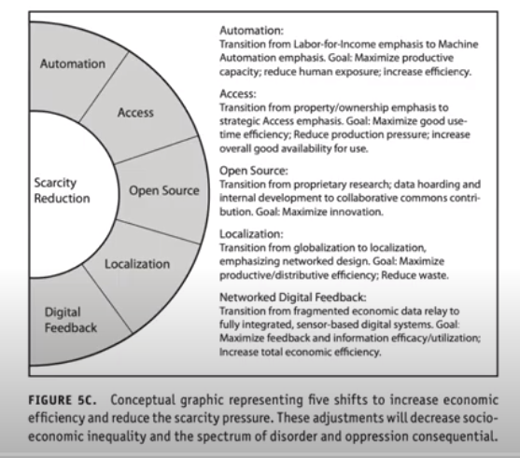

If we are going to have a functioning community that is actively meeting those important human needs, we have many big problems to take care of. There are all of the obvious material goods that make life possible and comfortable and continue to expand access to core technologies, but the philosophy for how to conduct and participate in those industries and simultaneously develop better systems also needs to be clear for everyone. Joseph’s model for scarcity reduction proposes just that, and we can let it speak for itself here. While the ethical sentiment expressed here is widely shared - for example, philosopher Peter Singer also gave compelling moral reasons and practical approaches for addressing famine and other kinds of scarcity - systems perspective can build on our shared concerns. However, we need to figure out how to generate and drive these systemic engines in ways that really work given the modern maze of human activity and motivation (or lack thereof).

**A Pragmatic Economy By and For Everyone**

Humans only get access to their higher functions and full potential if their survival needs are taken care of, as well as being cultivated into informed and creative people. That’s your life energy being set free and in a higher concentration, which then fuels the art and engineering and play that we generally prefer to spend our time doing. This is the basic premise for Maslow’s (outdated) hierarchy of needs, and it’s clearly relevant to the question of how to organize a functional society.

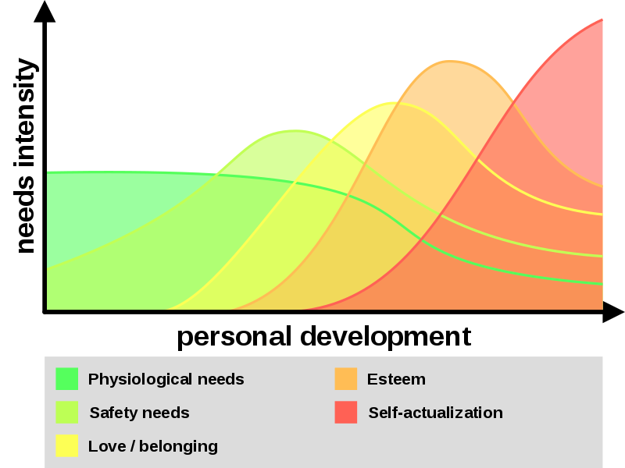

Here’s a progressive representation of the needs hierarchy from Wikipedia, which is to point out in general terms how different types of needs underpin a healthy maturation process through life. Each varies in relevance to our attention at different stages of self development, and some people may grow quicker than others along this paradigm as more of their needs are met. It’s apparent that each gets its due at different stages and they compound on each other over time, so really our needs become greater in some ways as our lives go on.

As you lose your ability to meet your base needs, the more time you’ll spend seeking those things and experiencing stress and generally going the opposite direction from “self-actualization” or more generally your overall autonomy while embedded in your environment. Your body needs all of that energy to grow and transform itself, and the more you are deprived of growth the more your mind is deprived of that possibility. This includes healthy social systems that look out for you and don’t take things from you unfairly, whether that’s your money, your body, or in general your time. Every second counts in this life, especially when you respect the delicate biology we float our existence on. Therefore, we need to take this aspect of human life completely seriously, and realize that yes there really are universal human rights to be met to ensure the growth of healthier minds, but more so there are systems we need to develop in order to maximize the potential of every individual, and assure access for every individual to those supportive systems. This inevitably requires everybody to be engaged and informed in some capacity, as every thread counts and has profound consequences on other people’s lives by proximity.

But who wants to slave away to build a system with no guarantees of positive returns or even plain gratitude, in a world where we already actively work against each other and find cynicism in even the optimistic efforts? Humans are inevitably flawed and are only slightly more developed than other intelligent species on this planet: our position at the ‘top of the food chain’ is precarious to say the least. But what if in our lives we’re capable of creating universal food, medical, housing, and transportation systems? What if people can still go and live wherever they want? What if we can achieve such a high margin of “productivity” or in better terms how easy it is to prosper that most of us end up serving shorter parts of our lives to drive this engine forward, spending the rest reaping the benefits? It is possible. This is a stark contrast to the lifelong no-guarantees work services that most people perform today, which generally only ends up making life easier for the very rich who can afford to lay around while their neoliberal/laissez faire/just plain corrupt pyramid schemes vacuum up wealth.

We know what is needed to drive a modern society on egalitarian and cooperative ideals and we have a lot of it already functioning in some places with varying degrees of success and accessibility. We know what people actually value in this system where things like luxuries and cash-grab fad industries seem to overwhelm practical and conscious businesses. It would not be difficult to organize funding to guarantee infrastructure and materials at a local level while creating proper incentives for reducing human input requirements (i.e. thus increasing efficiency). Eventually we would hit a critical point and generate more productivity and resources than we need—and that can be immediately extended to build better systems and take care of more people. Yet in the modern world, the trend is to pocket that wealth and move it somewhere it generally can’t be taxed, if the tax rates are even high enough to suffice in the first place. This state of affairs is eminently fixable—but only if we can re-constitute our social ethics into our policies and get enough people to sign on and enforce them. The only ones saying no right now are either the ones protecting their power, or the ones being manipulated by it.

**Co-operativized, Decentralized Innovation Engines**

At the end of the day, what establishes a new Google or Amazon or GE or AT&T, or semiconductor companies etc. is innovation and the ensuing market disruption. That isn’t a flashy new thing type of innovation, it’s coming up with something that can service infrastructure in a way that’s better than the current mainstream alternatives. Of course the other part of it for many of these actors is monopolization after a point, and Amazon and eventually Google or Microsoft will hopefully be broken up by antitrust enforcement. Otherwise this document is being written on a Google service because it’s free and it’s as good as anything we need, and before that we’d just use Open Office or a free hack of an old Microsoft Office version. It’s obvious the preference comes through not just convenience but the direct utility as well as the cross-integrations with all of the other Google Services and APIs out there that could let this document reach anywhere in the world and into thousands of websites. This is a solution to not just one design problem but hundreds through generalized and open access solutions, and it’s still not the best possible thing we could have.

However, what happens when someone comes up with “the perfect system” for this time period that maximizes all of our best technologies and ethics for reaching various human development goals? It wouldn’t make sense for it to be privatized for one due to that kind of power being wielded, and it’s not gonna be just someone. You’re talking about utilizing resources being inputted by essentially everybody on the planet. It’s something we’d all have to own and understand. Private groups delude themselves around intellectual property when in reality they’re just playing to an exploitative asynchronous market and could otherwise just as easily develop a product or infrastructure that people would simply use and contribute to to run their own services as well. This infrastructure-based mindset is a small leap of faith from the old Cold War business logic but it’s a necessary one to promote more action and collaboration over boring speculation and resource hoarding. This inevitably opens all kinds of research to everybody too and encourages us to make it more transmittable.

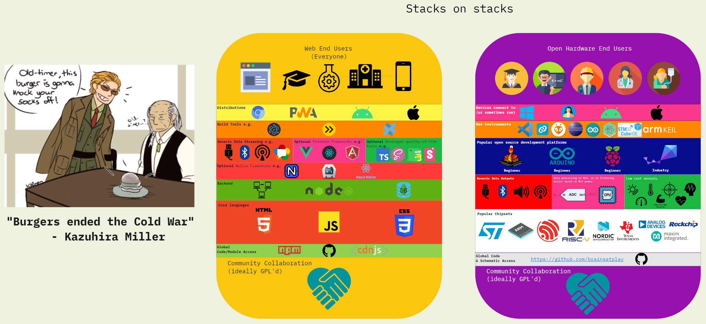

The Open Web and IoT revolution is powered by Free and Open Source Software (FOSS)!

The [Open Web](https://www.w3.org/) [23] project is a perfect example of this and is being done cooperatively as a consortium of big industry players. Those with the access and education for using or building web technologies are reaping the benefits more and more every day. The rules, brainpower, and energy required for software and development are being completely changed with it. Most people will only experience that as a change of the kinds of operations they perform on their devices to do their things or play their games, but on one level you can see it as entirely changing a set of behaviors being performed by a lot of people. That’s sort of the whole cybernetic human interfacing idea or more pragmatically what goes into industrial systems designs for cost savings or quality improvements in massive industrial complexes. There are plenty of grifts too (looking at you, Meta and Apple). Maybe that’s a bit devilish to think about, but it’s something that’s constantly considered by industrial engineers, UX designers, and even marketing teams, though often to the detriment of genuine innovation (rather they end up just trying to sell things we already know work rather than pushing for new functional systems, highly copied game design choices in the industry are a good example of this). We can appropriate such ideas into promoting *ethical action systems* as well.

Let’s give a little time to the idea of Innovation Management. Nowadays we have much clearer conceptions of the process of “supporting” current markets or “disrupting” them. It’s clear that business-as-usual requires symbolic and practical structures that are completely familiar and incremental to that established market or human system. Otherwise, disruption doesn’t mean “the new Apple,” with some new type of rounded corner on the box and some new proprietary scheme, it means entirely new perceptions, languages, modalities of access and sharing, and more.

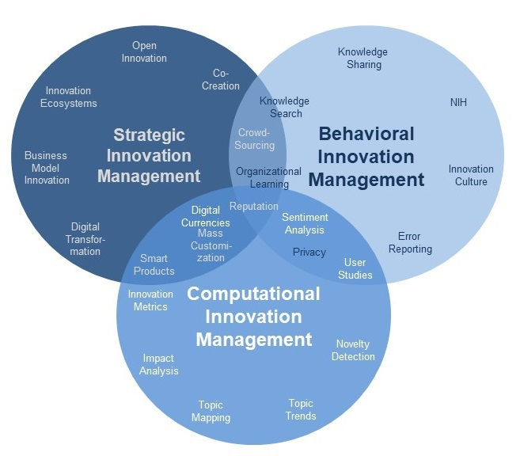

Credit: Aachen University

The latest generation does not know what the world without smartphones or high speed internet was like in the most fortunate areas. They also don’t know what the world was like with the biodiversity present a few hundred years or even just a few decades ago. That kind of thing is an entire disruption of the past cultural contexts the rest of us grew up in. More updated business education schools tend to embrace this rather than reject it, as it means entire new pools of opportunities - and you get to have a lot of input on who exactly those pools serve when you’re the one doing the disruption.

That’s why innovation needs to be a democratic process ultimately, one that is fully aware of how much we’re all writing the story and staging the world for the next independent experiencers and innovators of it. Let’s be clear that democratic doesn’t only mean “put it to a vote and don’t do anything until everyone agrees on something,” because that will never happen elegantly for every situation, but rather it also means that we all continue to develop and share our works as better solutions shake out - and we don’t forget to honor everyone’s time with the final fruits of theirs and our collective labor in the end. The technologies and thinking modalities that ultimately take over will still be a fairly uncontrolled sociological experiment, and fraught with danger, but an experiment nonetheless that we could all be so much more aware of, willing to educate ourselves about, and engage in.

**Co-operative Leap-Frogging to the Next Big Thing: The Game**

Once the material and social concerns are secured, then what? Well quite a few people are already more or less in this position within their small communities or if they’re young and/or fortunate enough to have a safety net. These people get to “play,” and the most devilish among them like to play with policy and entire state economies by throwing massive wads of cash at their favored solutions and accompanying lobbies. Groups like Koch Industries are infamous for this in the US, but now with centralized private media with the [Big 6](https://techstartups.com/2020/09/18/6-corporations-control-90-media-america-illusion-choice-objectivity-2020/) [24] it’s easier than ever to implement propaganda or otherwise psychological games. One of the spookiest examples was a [Sinclair broadcast](https://www.youtube.com/watch?v=C-4HOgULcd8) [25] implemented on dozens of centrally-owned local news stations where anchors repeated the same lines verbatim about the importance of democracy and independent decision making. The majority of the US (and well beyond now) leaves the same handful of news stations or centrally-owned radio and TV stations running non-stop in all stores, stations and speakers, along with other aggressive forms of advertising baked in to the point that it is one of the most propagandized countries in the world.

In contrast to what we normally see as propaganda - a centralised state-sponsored propaganda; here we see the same intentional use of symbols to evoke an emotional, cognitive or behavioral reaction. This is a different kind of narrative control implemented through overwhelming what are otherwise free speech systems with directing toward monochromatic worldviews - it’s double-plus good for ratings, and some social media platforms are designed in a way that encourages polarisation. Sometimes, the polarization can be a result of incidental entrepreneurs “gaming the system” with no political stake, as was the case with the Macedonian teenagers who made millions producing click-bait websites with outrageous and sensationalist Trump or Clinton-related content, after realising there is demand. This harkens to the state news stations of classic dictatorships, but with a more dynamical and difficult to follow system. The polarisation in narratives present in media, shallowing and intensifying of views have also been described as a feature of postmodern culture by Jameson, who talked about our “schizophrenic” culture, where depthlessness is occasionally countered by emotionally intense, outrageous claims and intense moments of extreme emotion [Jameson 1991], further perpetuated and intensified by popular media.

This type of brute force and high-intensity narrative and sensory control described above not only drowns out the true diversity and general realism of more informed public opinions - and to some extent is specifically designed to do so - and prevents more abundant citizen action through poisonous narratives and the ensuing paralysis we all feel in our own selves against a giant ever-shifting canvas of global activity. This process where the images and narratives in the media and culture stop representing any reality has been described by Baudrillard in his “Simulacra and Simulacrum,” where the presented reality in popular media is distorted and dissociated from anything verifiable. Its presence and pervasiveness undermines the shared understanding of the world that we need for healthy and empowered citizen action.

The same process visible in broadcasting media is happening with what is called ‘reflexive control’ of social media content, which is used by many countries. Those use state employees or even military personnel (e.g. U.S., Russia, China, and the UK), as well as private companies for hire to shift and confuse public opinion. One private intelligence firm (‘PSY Group’) is known to have pitched its services to the Trump campaign, a controversial religious sect in the Netherlands, and major politicians in the African country of Gabon. The company’s advertising slogan is ‘Reality is a matter of perception’ and their marketing material make claims about ability to ‘Shape Reality’ through using - to quote from their own materials - ‘gathered intelligence and broad expertise to build highly effective, targeted, online and offline campaigns’ ([PSY Group, n.d](https://journals.sagepub.com/doi/full/10.1177/1461444820902446#).). The company is for hire for anyone who can afford their services.

See, this kind of stuff is perpetuated by those with the time, money, and energy to sit down and craft systems involving thousands of moving people and parts - including using both traditional broadcasting groups and new media platforms. Most people are not educated to see these kinds of bigger decisions, choice architectures, and models at work as it all is easily lost in the tens of thousands of daily mundane exchanges between people about their lives and duties, while often finding their lives being laid out for them by these bigger systems and often against their better senses. The risk of losing comfort and stability, or worse death, makes this the perennial story for most of us who are forced or blindly led into the service of power.

On the flipside you have a bunch of random people with “particular sets of skills” flipping coins with the entire livelihoods of others. It’s Dungeons & Dragons for the wealthy and educated - their pawns a global servant class. This observation also applies to innovation and technological groups with zero union-type functions; those groups find tons of their employees on the chopping block every 3-6 months after betting the farm on big marketable technologies like video games. Everyone working under that flag becomes expendable after those quarterly goals are met and a new set of investors and executives are invited into the “brand.” Here fiscal policy is taking precedence over the real human efforts and histories underpinning their success, and the rewards are never given to the labor to nearly the same degree as they’re given to the gamblers rolling the dice with their heads simply due to their ‘creative control’ over the intellectual property.

So where are we going with this? Well the alternative is that we create a system so that “the next big thing” isn’t something we all have to ravenously claw for to win some betting game, rather it’s take all of that money that is highly skewed in its distribution toward the societal “gamblers,” give it to the people investing their priceless lives and talents in its creation even through unstable living conditions, and watch *them*, the true creators, develop as people and help the whole thing evolve and become a timeless operation. For working technological solutions to common problems in the current infrastructure, solutions targeting the problems that actually need to be solved in ways that benefit all, there might only be one or two best ways of doing things based on our resources. As a consequence, the “IP”’ possibilities aren’t as infinite (there is a limited number of good solutions) though their further application points may be. Either way it’s obvious these solutions should be shared and then used in a bigger iterative conversation rather than allowing those good solutions to be kept secret from others, while desperately protecting IP to guarantee the corporate innovators’ survival.

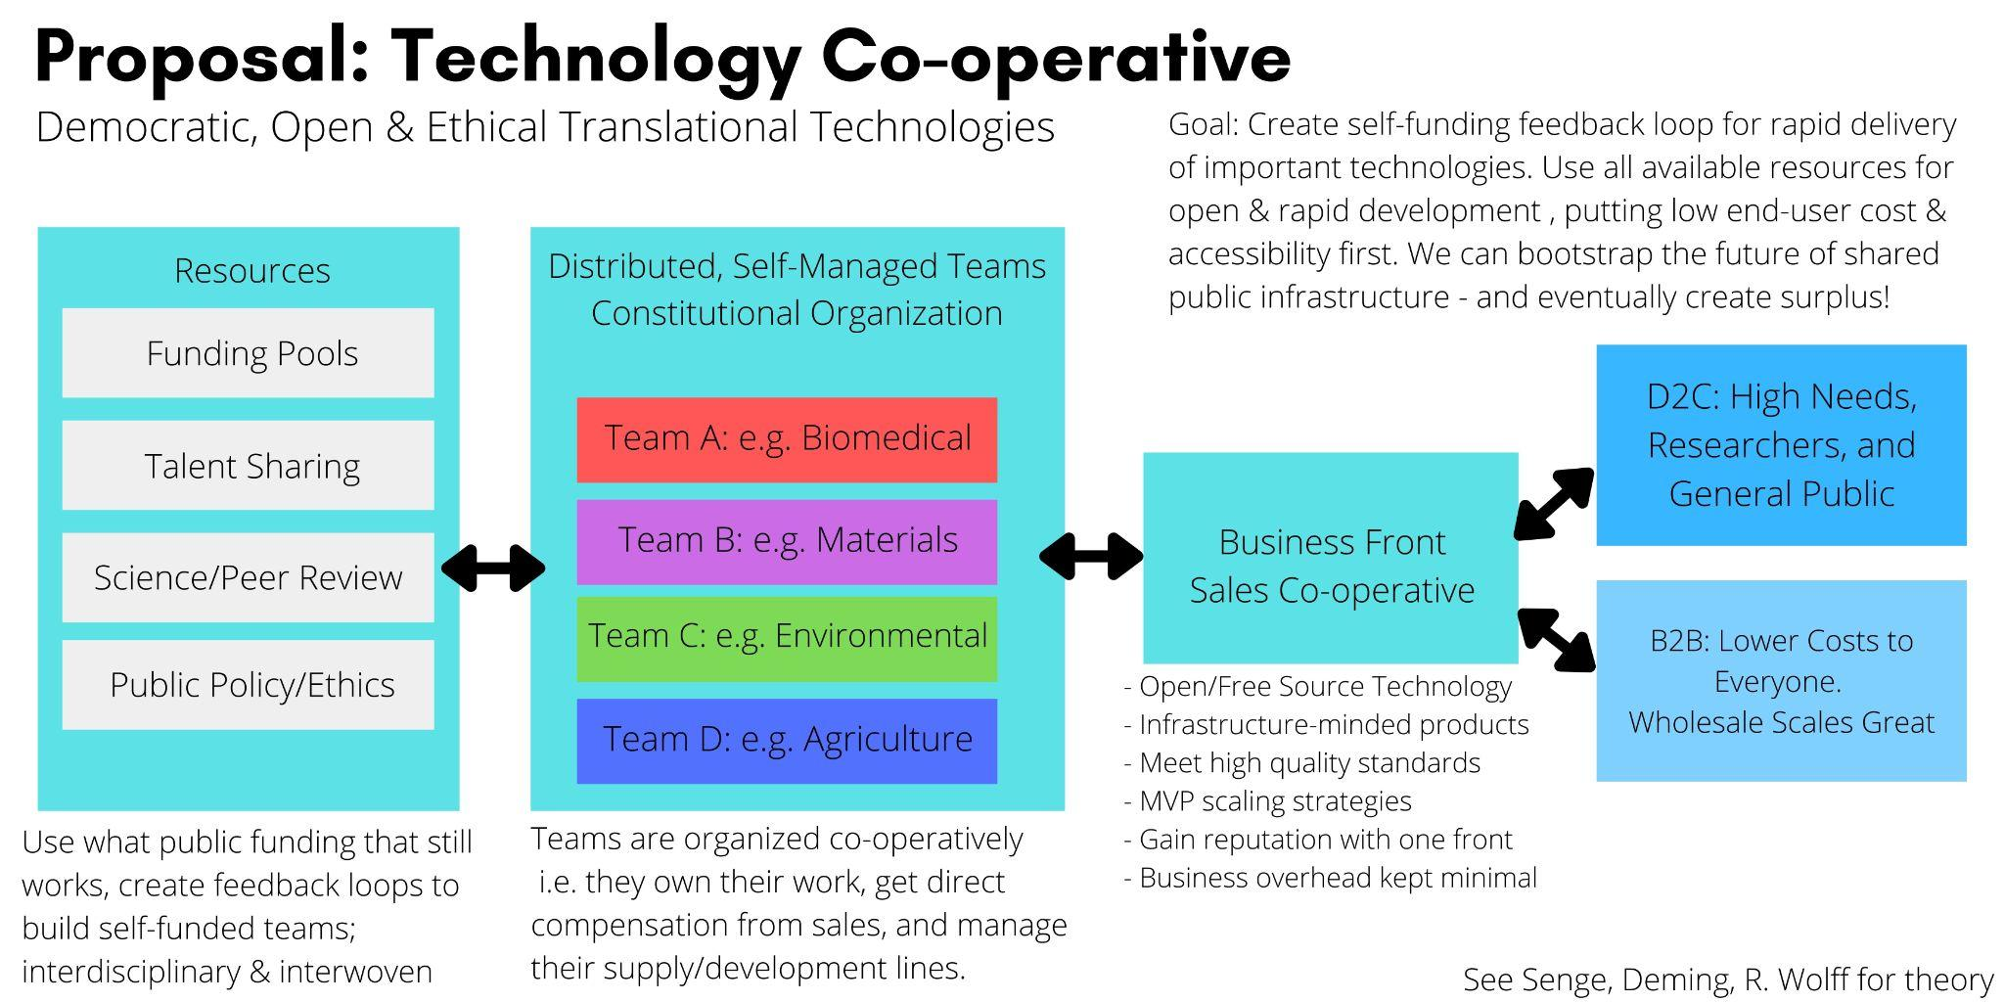

Yet again we get back to this idea that once there is surplus of resources through focused group efforts, and if we only grow that surplus through continually greater efforts, then soon enough we can distribute enough of it so we all get a seat at the table and can play with all the big ideas and arbitrary self-organization possibilities all together and knowingly. This is the essence of the idea around “Learning Organizations” popularized by [Peter Senge](http://www.theoryulab.nl/wp-content/uploads/2015/07/Executive-summary-Presence.pdf) [26] as well, one of the leaders at the MIT Sloan School of Management. We with our individuated talents find our natural roles within the projects we gravitate to very quickly, and when allowed independent voices and authentic listenership the creative magic between people is only amplified.

This can lead to better infrastructure with less time needing to be invested per person yet with greater reward and a greater sense that we’re all contributing. If within that process we’re allowing ourselves for our ideas and models to compete freely, and be able to do so without too much attachment or concern for status, we can have a focused discourse to generate ideas and build new as-yet unfathomed theories, infrastructure, art, and general transformational possibilities for more peoples’ lives. That’s the cultural scientific process in a nutshell, but it can be made so much louder with the understanding of its potential for our health and art and our often quiet yet significant independent roles in pushing everybody forward.

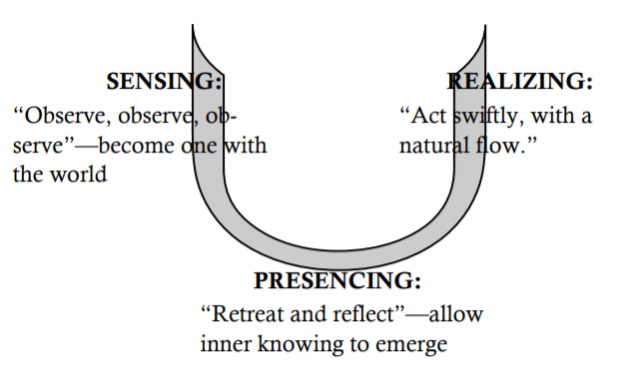

In Presence by Peter Senge, Otto Scharmer, and colleagues, they propose that we think of this through our individual lives as a process of repeated, informed, reflective self-transformation that looks like the above. This importantly involves a sense of letting go as we move from less integrated to more integrated concepts, to move beyond the constricting internal self control and awareness systems we may have developed using less complete ideals and developmental strategies or left over from neglect and illness. You can even think of this as just your brain developing from childhood to adulthood and the immense amount of wiring that has to occur in that time, but this process starts all over again when it comes to developing new conceptual frameworks in our perception. It is obvious that most of us are constantly engaged in this process, whether struggling against our health or our culture, but it’s a lot harder to do the first few times if we are successful at all, as it’s a kind of skill that requires a lot of our faculties. So, facilitating a culture that lets us engage in these self-transformational processes fully, and more openly and earnestly, is required to enable us to form those new, more functional networks, which is key in the process of cooperativization.

While Learning Organizations are packaged for giant corporations or public officials who can afford leadership training to begin to develop actual human sensitivities into their mechanical profit-maximizing systems and policies, these ideas are informed entirely by how small villages function and form reliable networks with their neighbors. The oldest kinds of societies we ever formed were able to much more naturally grow around both the obvious and not so obvious human needs we all have and the constraints of the environment, and you don’t need to look any farther in most cases to learn what communities ought to look like in terms of the kinds of deep interpersonal and ecological connections. You also don’t need to look any further in any part of the world to see how the modern world’s lost sense of self has impacted people the worst, as these places often now see some of the worst poverty, health outcomes, and domestic violence. This can include many absorbed and forgotten neighborhoods in our endless metropolitan sprawls.

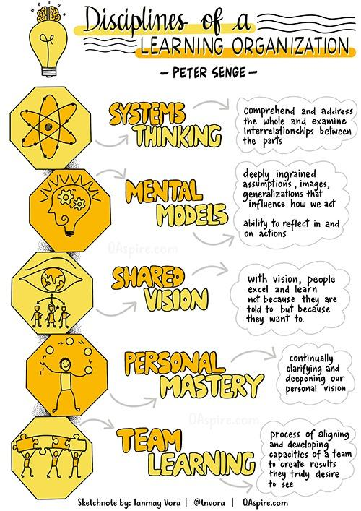

Interpersonal organization is clearly a natural technology of its own, though it’s hard to see it outside the scope of families and roles and our individual identities and mental tracks within these larger schemas. As we all learn to harness it, not for power or short-term comforts but instead for the shared joy of living, then the more we stand a shot at building true, trusting co-operative societies. Those societies can bring us into the next decades with an ironclad sense of justice, collective fortitude, and commitment to each other and our works as part of a bigger group, or even as participants of an amazing planetary developmental process we’re all taking part in.

**The Importance of Excellence**

Learning is ultimately an iterative and stumbling, multi-generational process. Just watch a computer try to make a robot walk, it takes time leaping from inferior to better control systems all through just continually organizing and reorganizing its internal wiring around better, broader priors. Eventually it gets so good it’s flawless in some respects at running, jumping, etc. until you introduce it to novel situations and it has to start all over again - say asking it to now scale a cliff. If it’s built for it, it will figure it out. These are machines with no sense of failure as being anything but a learning experience. They are starting to go from mastering a few tasks to blending full spectrums of behaviors to achieve new novel goals. The special sauce here is from very simple but nuanced reinforcement learning and environmental inferencing algorithms, which can produce simple models that in turn translate to efficient computation in real time. These computer systems can fire on all cylinders at all times, because it only demands an electrical power source, and this has ended up rapidly outpacing individual human learning and maximum potential accuracy in areas like medical imaging or simply moving boxes.

What would it take for a human to then turn around and beat the computer? Realistically, any one human probably can’t in areas around the main body of game, motor, and imagery tasks we’ve successfully applied machine learning and robotics to. Human accuracy after a point can only be improved by machine modification or, perhaps, group consensus. [A famous example](https://theconversation.com/how-to-unleash-the-wisdom-of-crowds-52774) [27] averaged the best guesses from professional oceanographers as to where a submarine wreck had hit the seafloor, any single guess mostly did not come relatively close to the actual landing site, while the averaged guess fell a few hundred yards shy of its final resting place. This is the spooky ghost of collective reasoning that keeps a lot of us up at night, while it’s also just the way our brains work by themselves. This is the “wisdom of crowds,” a contrast to the animal collective unconscious of human society that guys like Edward Bernays took advantage of to market us things like cigarettes and create the consumer identity, a re-packaging of propaganda for mass marketing and public relations, though it does exploit similarly averaged statistical realities of human decisionmaking.

One common thread between these individual and group learning examples is an optimism that there is always a better way, limited only by the deftness of the models being observed and the usable systems those models are meant to be applied to. Humans tend to have a lot of confidence issues here, or really just not a lot of time and energy to fully engage this side of ourselves. When you get into the competitive academic and industry sphere, you tend to see a kind of Pavlovian self-reinforced hyper-specialization in a rat race for higher-paying roles and golden goose research grant roles. This process creates some of the most talented and over-educated people in the world, but often without a broader base to reflect on at the end of the day to really push their skills and personal engagement with them to the maximum.

As well, without broader networks to engage with, we are really limited in our true problem solving and creative capacities as so much of that happens between the lines through freely exchanged ideas and constructive criticism. Academia has simultaneously constructed one of the most sophisticated networks for this as well as one of the most frictional, generally due to monetary incentives and deadlines that tend to kill the core R&D and sharing mindset as soon as there is the ability for product delivery or whiff of potential profit. Any long term minded group knows the answer is to stake your progress along the way with work that can feed the family and only strengthen the innovation process with reinvestment and empowerment of its people. If we make “its people” non-exclusive even beyond just humans, then we get into global systems thinking and understanding that passing the torch of the great human experiment for a few hundred more generations is going to take open-minded input from all of us in all corners. This especially comes in light of the world’s borders in the sand melting away amidst climate, political, and cultural disruption - along with the overwhelming burden of the globalized industrial systems we all immediately rely on.

This brings us to the key ingredient here to making a more optimistic and broader serving system: you. That’s the you that’s stumbling in the dark, maybe with your hands on someone you bumped into’s shoulder as you stumble around together. Humans for the past who-knows-how-long, and maybe by accident, have cultivated a big web of connection with their candles lighting the way, each person a solar system of their own, tangled in gravitational wells of history and language and personality. This web finds ways to reinforce its best models even through many pitfalls, and that continues to bring more of us up into an appreciation and more fuller engagement with all of the complex and beautiful systems on Earth and across this universe. Human culture and the sciences embedded in it have been fueled by this process across generations. The more we can bring this understanding to the forefront of all our minds and challenge our skills more openly, the more we may find the collective strength to meet our most urgent earthly challenges and restore an optimistic sense of the future, as well as fully realize our individual significance within this big turbulent sea. The alternative is a Hobbesian universe where life is as “solitary, poor, nasty, brutish, and short” as life in the primordial ooze we emerged from. At this point the question is which universe do we want to create?

**Systems Intelligence**

We need to get this idea out of our heads that humans are by default fallen creatures, when we’re mostly just smarter and more creative upright apes with all of the baggage. This is something propagated by orthodoxies, fundamentalists and authoritarians across the world, while it only serves to cut you off from something completely innate to us, which is this understanding of things coming together in ways not so explicit around us - especially in our social lives. It seems to be that this is what really enables our creative and inherently fluid ability to adapt to the ever-changing world, so if you can bottleneck that perception you can generally determine how humans will grow into people - including all of their precepts. Your perception itself is then threaded through the eye of the proverbial needle rather than being allowed to grow normally outside of such indoctrination. It’s like how we can bind and graft trees to train them into all kinds of odd shapes, where they still seem to be able to live just fine but it’s just not a situation you see in the wild.

Amusingly, the far right in the US uses all of the same logic to say that this is why they need to shut down other narratives in favor of their own dogma, but you can always find bottlenecks filtering their reasoning, e.g. they’re dogmatic about their particular books or misinformed, belligerent, and privileging interpretations of history. No ideological interest groups are free of certain forms of denialism generally, that’s often how those interest groups form. The nuance of what resilience and cultivation really looks like in greater human society is lost in a myopic or ahistorical framework. One thing with brains is we can literally only see in others what we’re capable of seeing in ourselves, and that includes input from all of our senses - including our internal models. This is a certain kind of blindness, let’s say systems blindness, and phenomena like groupthink are incredible at enforcing it. We all experience this growing up through the school of hard knocks and being scolded for the dumb or sometimes violent stuff we do as kids, and through hard rejections and tragedies that we fail to understand or prevent. Many things we learn just by letting our brains mature in a healthy environment, because timeless millennia have already learned a whole lot for us, including nuanced and multidimensional communication with others - it’s not possible [without organs](https://en.wikipedia.org/wiki/Body_without_organs) [28].

Ironically, fundamentalist religions tend to focus on the way to separate ourselves from that timeless and unfathomably complex embodying process that made us who we are today, including divorcing our life stories from both long and near term human history. They instead get framed into a packaged narrative, rather than the one right here and now that we’re all adding to every moment. Fortunately/unfortunately, it’s that terrifyingly open, very fragile, complex dynamical process we’re embedded in that makes us, and only if we reach further with learning its at once wholly intuitive and unintuitive principles rather than beating them back to sate our feelings and fears of inevitable death, then the more we may find connection to each other within that and more reasons to keep this show going to make it a good time for all the others who were born into it without asking.

Systems intelligence is natural ethics in the modern world. Or paraphrasing Peter Senge, it’s the knowledge and appreciation of life itself as it’s happening around us. There are scale-free dynamics throughout natural systems, and they don’t just disappear when you get into the human social realm. This relates heavily to the entropy theories this paper was inspired by, which point to a fundamental scale-free process of things forming and holding patterns through various energy transformation scenarios and with any arbitrary numbers and sets of objects often with so many overlapping interactions it’s only detectable as noise. Life as we know it in a way is almost inevitable in this process, the universe simply refuses to be barren, and we’re here to witness and facilitate. Or to paraphrase Peter Senge again, we’re not just the species who grasps but the species who caresses, and it’s only because of that love of the natural world and the grace of its emergent diversity that we have become sophisticated enough to sit here today and read this through our amassed technological and civic achievements.

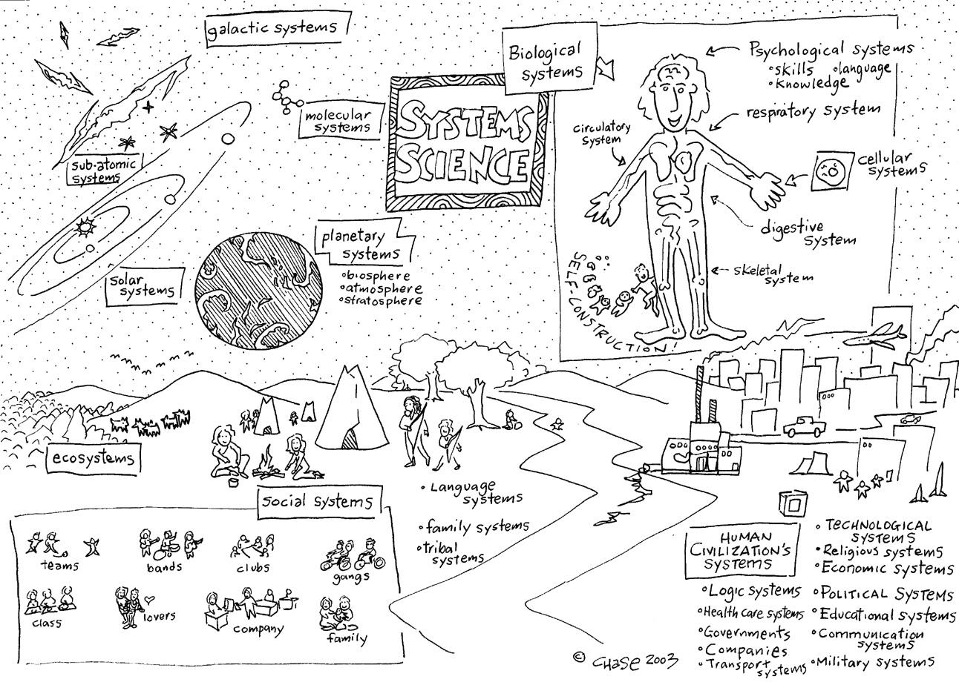

A systems science diagram by [Christopher Chase](https://creativesystemsthinking.wordpress.com/author/creativesystemsthinking/) [29]

While this worldview is one that may be incomplete, it is one of the only ones that challenges us to assume nothing is incidental from each grain of sand or insect or mushroom, all the way out to the cosmic web. This isn’t to say any of it’s somehow ‘special’ other than to highlight the universe’s infinite capacities for depth in evolutionary processes. We don’t want to become systems astrologers. Real scholarship requires us to honor our history and sniff out all of the details in earnest, and to honor the sensitive and loving connections really at the heart of human society, one that can only be improved through the health of the whole planet in all of its complexity. There’s no need to oversimplify the story, while there still exists elegant axioms and control systems to work in any part of it effectively and not in isolation. Again, this is just innate to humans, our entire biological nervous system rests on dozens of constantly unfolding dynamics which gives it its ultimate flexibility, resilience, and adaptivity - as well as reproducibility.

**Putting it All Together**

So we have a bunch of terms that give us a bunch of neat pictures in our heads now, what is the practice we are trying to implement here? Well that’s a lot you have to figure out for yourself, but sit on that sense of greatness you know is there in you and figure out what the hell it needs to not be a washed up pseudointellectual schmuck. If that’s taken care of, this should be pretty obvious stuff next. Since we’re talking systems, let’s map a possible way of thinking that won’t fail to honor every ounce of real and potential grace and nuance we could all be flowing with thanks to the wonders of the natural world. Hopefully this can be a somewhat useful contribution to the ineffable symbolic framework of life and togetherness being painted by world history and human creativity, and help us meaningfully organize our thoughts and practices into the future.

In order to find real information about and make transformations to systems which are currently embedded in higher dimensional structures i.e. bigger systems, you must first project its known behaviors up to the higher dimensional (i.e. systemic) space and use current best measurements of the whole field to infer down and find the actual potential energy/state/trajectory of the subsystem. Interactions at the subsystem (i.e. local) level are highly entangled with other connected subsystems/localities and incur chaotic reactions in a probabilistic flow with each other that cannot be easily measured locally.

Let’s reword that for humans. In order to know the total health and potential of a human, you must first find out the health of their environment and history, then use the known patterns and realities of individual human behavior to infer how likely they are to be in different situations currently or in the future. People are so complex and embedded in their day to day lives that these greater flows of societal energy and emotion acting on their lives can be undetectable from their frame of reference, while certain outcomes will be statistically inevitable for at least somebody. Knowing the rules of the different systems and projecting forward from inference based on real observations of the individual and their past as well as surroundings can then let us draw probable conclusions about their health. That’s proper medicine.

For instance, we know that if about half of the American population has childhood trauma qualifiable as Adverse Childhood Experiences (ACEs), we know that a certain percentage of those groups will be dealing with chronic mental and physical health issues. This amounts to nearly [half a trillion dollars](https://www.cdc.gov/policy/polaris/healthtopics/ace/index.html) [30] in health care costs when it all is added up according to the CDC. More importantly we know that any given person we meet in the US has a one in two chance of having seen some serious neglect or life-changing horror in their lives and may be mentally and physically held back by it. This implies always giving a certain amount of respect and pause to others on the basis that we’ve all likely seen suffering and we all could use more opportunities to move forward and be welcome in the world, and we don’t want to be the ones to step on that for others if we can instead be another link in the network in some way.

This leads to a sort of inter- and intragenerational symbolic model to view life as a people and our ever-recursive influences on each other and through generations and changing environments. Let’s recall Tagore’s ideas of Indian society emerging from the dynamics of the forests ancient Indians emerged from and provide some imagery to blend the system hologram and the forest as a symbol of human life and what makes it. We could call it the infinite tree-knot.

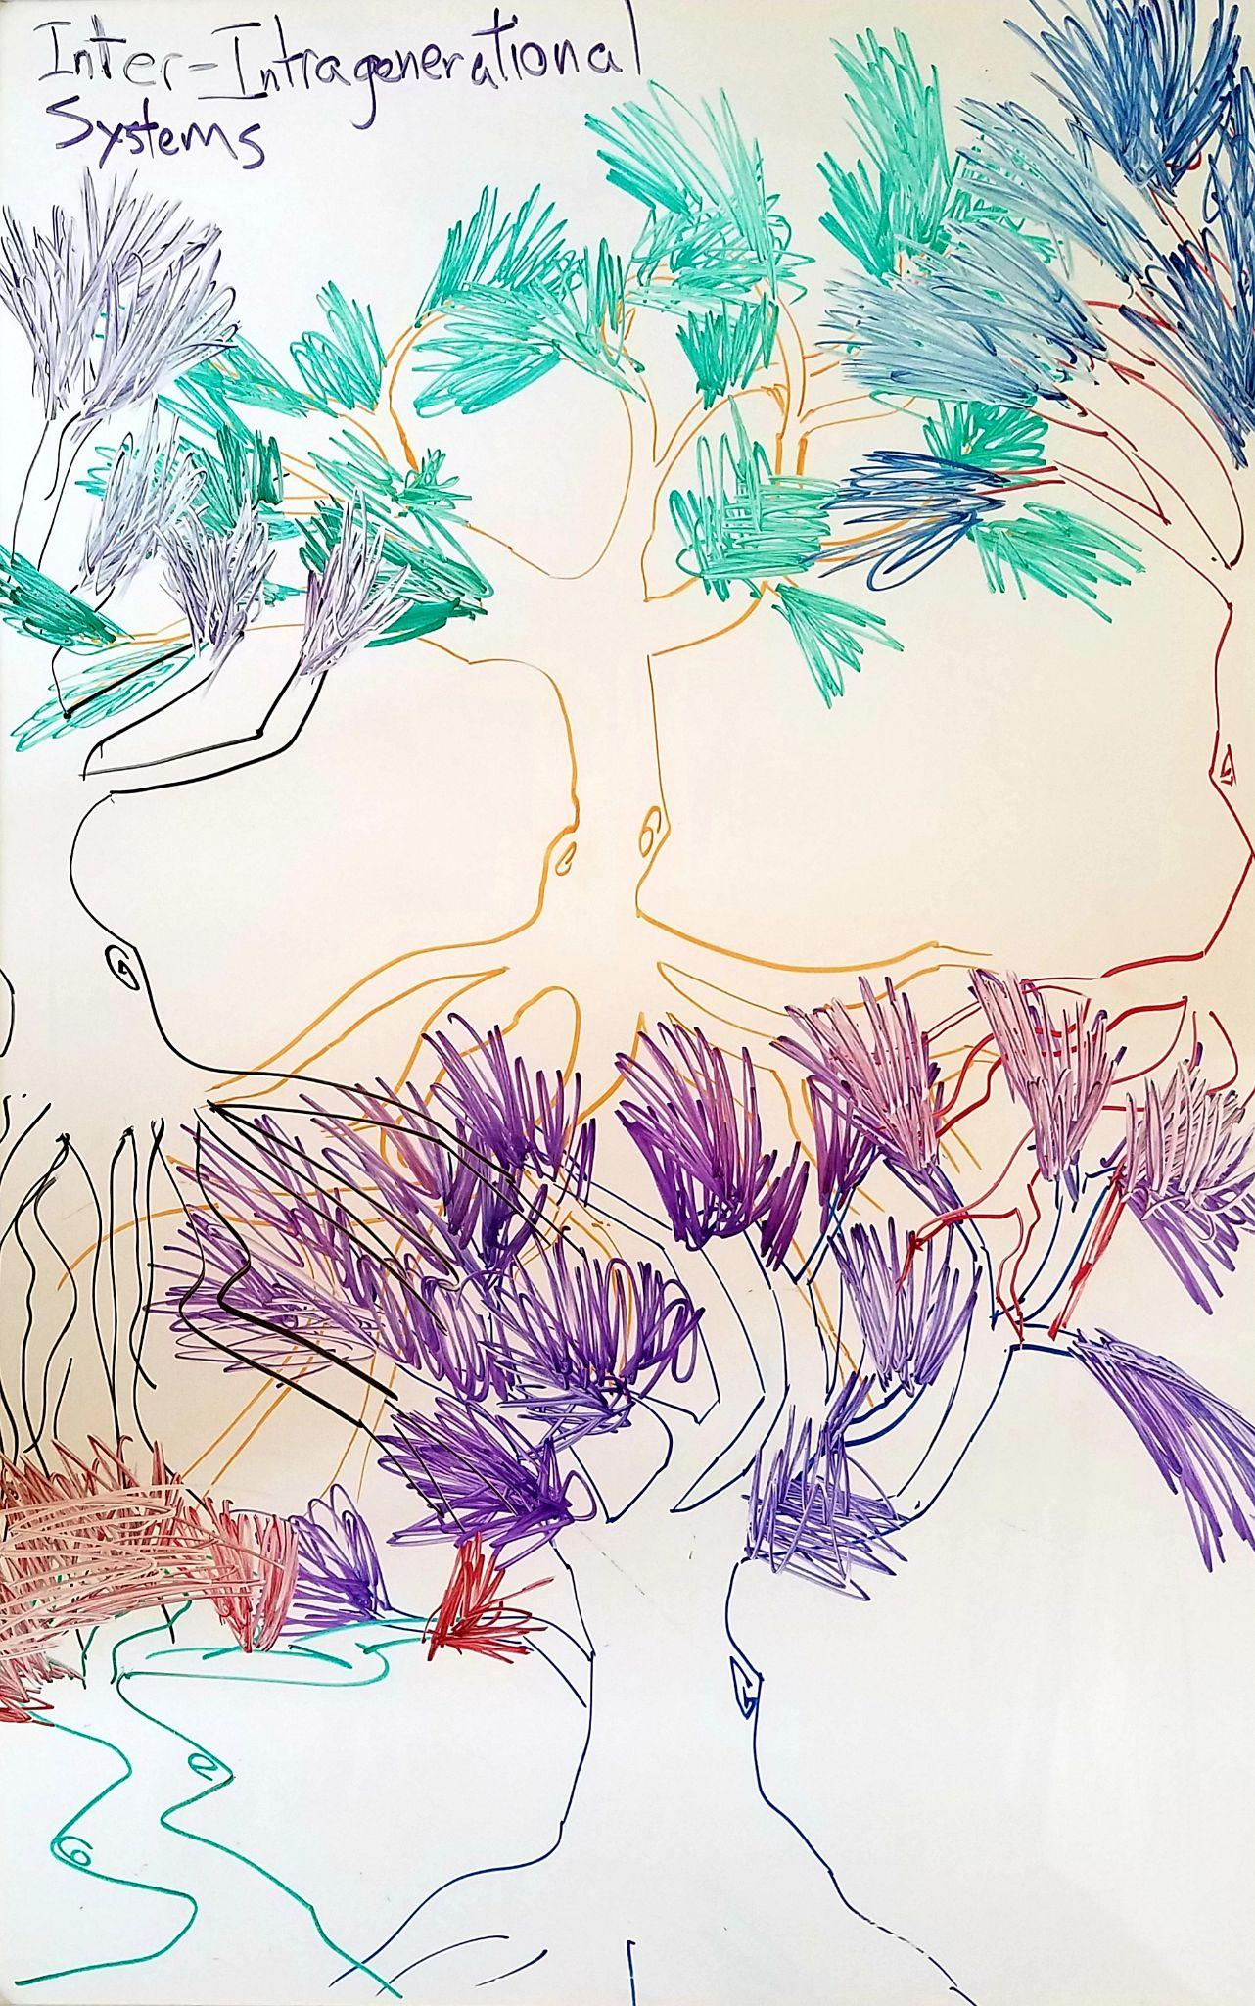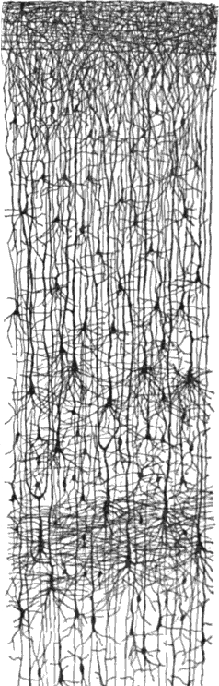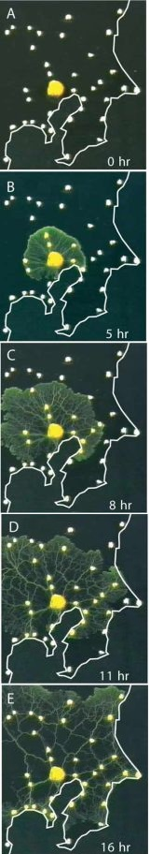

We’re juxtaposing this next to the layers in a column of the neocortex as well as a slime mold searching for food on a map of tokyo and optimizing its pathways, to convey the idea of generations of natural systems being inseparable symbolically from the convoluted but very natural mess that produces our consciousness and the furthest extents it may be able to reach, where in neurons we see similar generational layers and filtering schemes but laid out much more literally in biological computation schemes. All that’s missing are the rivers and geology and everything else that goes into a natural system, but you can interpret the relationships as this ever-compounding and complexifying sort of hologram of life connecting in its current day and throughout time.

Essentially, we cannot disentangle ourselves from our communities and the intergenerational conversations that have profoundly staged our lives. At the point one person is suffering, everybody is suffering, and from a top down view you cannot know which individual it may be as it could happen to anyone. This comes to the core reason to ensure the networks we cultivate are nonexclusive and put our natural needs through our lives first, knowing that the world beyond that is one we’ll all be able to appreciate and add to. Current education systems worldwide are still not the most apt at making this systemic reality our main mode of seeing the world. When you’re brought up never knowing these things yourself, how will you know how to propagate them responsibly and not end up stranded in another rigid ideology that doesn’t see the ever-fluctuating and time-dependent whole of human and planetary life that we’ll be entangled with as long as the Earth has gravity and our genes are shared with everything else?

**The Future?**

By now we hope you’ve all realized we’re careening off a cliff as these grand yet phantasmagoric systems at work in the world - accelerated by some twisted relationship with our biology and consciousness - threaten to eat us alive while most of us remain none the wiser. There are ways to educate, empower, organize, and transform communities one by one if we can get people together to start to openly collaborate and organize their societies around more survivable principles like we’ve tried to highlight here. There are ways to create a planet that is more full of life and can feed even more. There is a lot of confidence required to invoke new awareness in others, but this is one that naturally comes through the wisdom that we all should be gaining from our active learning and development of our already incredibly wise brains. If not, more people are going to die and suffer needlessly, plain and simple, and more people will never have the opportunity to see and experience the world in earnest or see anything really worth reaching for, instead caught in some ugly hall of mirrors.

*It seemed that in the coming storm all the dearest things must be destroyed. All private happiness, all loving, all creative work in art, science, and philosophy, all intellectual scrutiny and speculative imagination, and all creative social building; all, indeed, that man should normally live for, seemed folly and mockery and mere self-indulgence in the presence of public calamity. But if we failed to preserve them, when would they live again?*

*How to face such an age? How to muster courage, being capable only of homely virtues? How to do this, yet preserve the mind's integrity, never to let the struggle destroy in one's own heart what one tried to serve in the world, the spirit's integrity?*

*Two lights for guidance. The first, our little glowing atom of community, with all that it signifies. The second, the cold light of the stars, symbol of the hypercosmical reality, with its crystal ecstasy. Strange that in this light, in which even the dearest love is frostily assessed, and even the possible defeat of our half-waking world is contemplated without remission of praise, the human crisis does not lose but gains significance. Strange that it seems more, not less, urgent to play some part in this struggle, this brief effort of animalcules striving to win for their race some increase of lucidity before the ultimate darkness.*

* Olaf Stapledon, *Starmaker* 1937 (written anticipating WW2)

We encourage you to read, to find sources of wisdom, and to reach out to each other relentlessly, to build caring communities, and to help each other find our collective way to a better, more colorful, more optimistic world. Everything is in place and happening now and there needs to be a whole lot more of it, and organized under a common understanding so we can make one big transformative push on policies and infrastructure the world over in a highly coordinated fashion. We don’t really want to think about the alternatives, though they’re breathing in our face at this point.

Back to the original kerfuffle with misappropriated physics models: the convergence point for creating a system with maximal entropy i.e. knowledge and possibility for humanity and the Earth in general will be when all of us are empowered, fully aware, and able to move forward or have someone move us forward with them. Only then will we see that transformation from this fragmented, disparate global community into something a bit more functional and a whole lot more livable. Ancient nomadic societies seemingly had a lot of this figured out as they crossed each others’ paths peacefully. Ancient Andean human networks saw something like a thousand years of relative peace through a unified view of their community through the mountain range, and that was not unique in ancient South or Central American societies. These societies also were known to cultivate and shape their landscapes more harmoniously with nature rather than leave them stripped and barren. It’s all possible, and it doesn’t need to be based on misleading myths or forced behavioral modification through economic brutality, but rather through the genuine optimism and wisdom that most of us carry and are fully capable of acting and synchronizing on as we further cultivate life.

We want you to understand that much of this is also inspired by the radical tradition that’s existed in the Americas and beyond. Every inch humanity has gained in the past few centuries was hard fought and required mass organizations. We cannot let those efforts by our ancestors just be flashes in the pan in a last cry for global justice, there is a lot more work to be done.

“*Reality is under assault. Verbal confusion reigns. Truth and illusion have merged. Mental chaos makes it hard to fathom what is happening. We feel trapped in a hall of mirrors. Exposed lies are answered with other lies. The rational is countered with the irrational. Cognitive dissonance prevails. We endure a disquieting shame and even guilt… We must build communities where we can find understanding and solidarity. We must allow ourselves to mourn. We must name the* [*psychosis*](https://www.youtube.com/watch?v=ythOLteROK0) *[31] that afflicts us. We must carry out acts of civil disobedience and steadfast defiance to re-empower others and ourselves. We must fend off the madness and engage in dialogues based on truth, literacy, empathy and reality. We must invest more time in activities such as finding solace in nature, or focusing on music, theater, literature, art and even worship—activities that hold the capacity for renewal and transcendence. This is the only way we will remain psychologically whole. Building an outer shell or attempting to hide will exacerbate our psychological distress and depression. We may not win, but we will have, if we create small, like-minded cells of defiance, the capacity not to go insane.*” - Chris Hedges

**Appendix**

Helpful Media List

<https://www.youtube.com/watch?v=2HwFOo5rbZA&list=PLqBDx6bFF1SzzFJ3FHaKhQJ7j-UKDsqEn&index=1>

**Citations**

1. Gnosis.org. “The Corpus Hermeticum and the Hermetic Tradition” The Gnostic Society Library<<http://gnosis.org/library/hermet.htm>>
2. G.R.S. Mead. 1907(?). *Commentary on the Pymander (Poemandres)* The Gnostic Society Library <<http://gnosis.org/library/hermet.htm>>
3. Gloria Dickie. 10/13/2020. “The Arctic is in a death spiral. How much longer will it exist?” The Guardian. <<https://www.theguardian.com/us-news/ng-interactive/2020/oct/13/arctic-ice-melting-climate-change-global-warming>>
4. Katharina Fabricius et. al. 2020. “Progressive seawater acidification in the Great Barrier Reef continental shelf” Nature. <<https://www.nature.com/articles/s41598-020-75293-1>>
5. Caryl-Sue, Nat Geo. 2019. “Great Pacific Garbage Patch” National Geographic <<https://www.nationalgeographic.org/encyclopedia/great-pacific-garbage-patch/>>
6. Andrew Keshner. 2/24/2019. “America’s 1% hasn’t had this much wealth since just before the Great Depression” Market Watch. <<https://www.marketwatch.com/story/its-been-almost-a-100-years-since-the-americas-1-had-so-much-wealth-2019-02-11>>
7. Anand Giridharadas. 1/9/2019. “The New Feudalism” New Economic Thinking. <<https://www.youtube.com/watch?v=n-2TEwdRnX0>>
8. 2020. “The State of Mental Health in America” Mental Health America. <<https://mhanational.org/issues/state-mental-health-america>>
9. Astha Rajvanshi. 1/19/2021. “India’s farmers raise alarm over endemic poverty” Institute of Current World Affairs. <<https://www.icwa.org/india-farmers-raise-alarm-over-poverty/>>
10. Erwin Schrodinger. 1935. “The present situation in quantum mechanics: a translation of Schrodinger’s ‘Cat Paradox’ paper” John D. Trimmer. <<http://hermes.ffn.ub.es/luisnavarro/nuevo_maletin/Schrodinger_1935_cat.pdf>>
11. Leandro Aolita et. al. 15/2/2014. “Open-System Dynamics of Entanglement” Reports on Progress in Physics. <<https://arxiv.org/abs/1402.3713>>
12. Rod Swenson. 1997. “Thermodynamics, Evolution, and Behavior” Center for the Ecological Study of Perception and Action. <<https://www.ethics-based-on-science.com/uploads/2/8/5/1/28516163/mjm-notes-entropy-and-evolution-ordered.pdf>>
13. Mathias Albert, Felix Bathon. 3/5/2020. “Quantum and systems theory in world society: Not brothers and sisters but relatives still?” Sage Journals. <<https://journals.sagepub.com/doi/10.1177/0967010619897874>>
14. Earl Miller. 5/15/2020. “Working Memory 2.0” MIT Department of Brain and Cognitive Sciences. <<https://www.youtube.com/watch?v=xBwl_bUDMaM>>
15. Robin Carhart-Harris et. al. 2/3/2014. “The entropic brain: a theory of conscious states informed by neuroimaging research with psychedelic drugs” Frontiers in Human Neuroscience. <<https://www.frontiersin.org/articles/10.3389/fnhum.2014.00020/full#B160>>
16. Donald Hoffman, Suzanne O’Sullivan. 2/7/2019. “Reality Is Not As It Seems” New York Academy of Sciences. <<https://www.youtube.com/watch?v=3MvGGjcTEpQ>>
17. BBC. 3/3/2017. “Amazon forest ‘shaped by pre-Columbian indigenous peoples’ BBC. <<https://www.bbc.com/news/world-latin-america-39149334>>
18. Brian Barth. 4/19/2016. “Permaculture: You’ve Heard of It, But What the Heck Is It?” Modern Farmer. <<https://modernfarmer.com/2016/04/permaculture/>>
19. Simon Fadaee. 9/3/2018. “Harvesting Hope: the Permaculture Movement in India” Resilience. <<https://www.resilience.org/stories/2018-08-03/harvesting-hope-the-permaculture-movement-in-india/>>
20. Vandana Shiva, Fabian Scheidler, Nermeen Shaikh. 9/15/2020. “Ecocide, industrial agriculture and the Megamachine” Democracy Now. <<https://www.youtube.com/watch?v=6Eymv-PaJsw>>
21. Vandana Shiva. 5/3/2019. “Everything I Need to Know I Learned in the Forest” Yes Magazine. <<https://www.yesmagazine.org/issue/nature/2019/05/03/vandana-shiva-seed-saving-forest-biodiversity>>
22. Peter Joseph. 2018. The New Human Rights Movement: Reinventing the Economy to End Oppression BenBella Books, Inc.
23. Nickie Louise. 9/18/2020. “These 6 corporations control 90% of the media outlets in America. The illusion of choice and objectivity” Tech Startups. <<https://techstartups.com/2020/09/18/6-corporations-control-90-media-america-illusion-choice-objectivity-2020/>>
24. World Wide Web Consortium. <https://www.w3.org/>
25. The New York Times. 4/9/2018. “How Sinclair Broadcast Group Violates Its Own Media Rules” The New York Times. <<https://www.youtube.com/watch?v=C-4HOgULcd8>>
26. Keith Walker. 2005 “Presence: Human Purpose and the Field of the Future, Executive Book Summary” <<http://www.theoryulab.nl/wp-content/uploads/2015/07/Executive-summary-Presence.pdf>>
27. Thomas Hawk. 2/9/2016. “How to unleash the wisdom of the crowds” The Conversation. <<https://theconversation.com/how-to-unleash-the-wisdom-of-crowds-52774>>
28. 2021. “Body without organs” Wikipedia. <<https://en.wikipedia.org/wiki/Body_without_organs>>
29. Christopher Chase. *Creative By Nature*. Wordpress. <<https://creativesystemsthinking.wordpress.com/author/creativesystemsthinking/>>
30. 2021. “Adverse Childhood Experiences” Center for Disease Control and Prevention <<https://www.cdc.gov/policy/polaris/healthtopics/ace/index.html>>
31. Chris Hedges, Amanda Zackem. “American Psychosis - Chris Hedges on the US empire of narcissism and psychopathy” American Canary. <<https://www.youtube.com/watch?v=ythOLteROK0>>

We are missing citation links from Anna Pacholczyk’s sections (when the z’s turn to s’s) but the author’s names are cited.